

Problem Statement

Host a static website using AWS

Overview

* Create a S3 bucket.
* Creating HTML, CSS and JS code.
* Uploading file in S3.

Solution

Creating S3 bucket

* Login to AWS console.
* Navigate to S3 service using search bar.
* Select bucket and click on create new Bucket.
* Enter Bucket name and leave else as default.
* Go to properties and edit static website hosting.

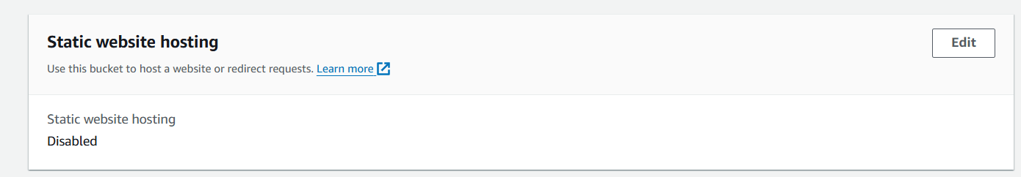

* Enable web hosting and enter Index.html in index document section.

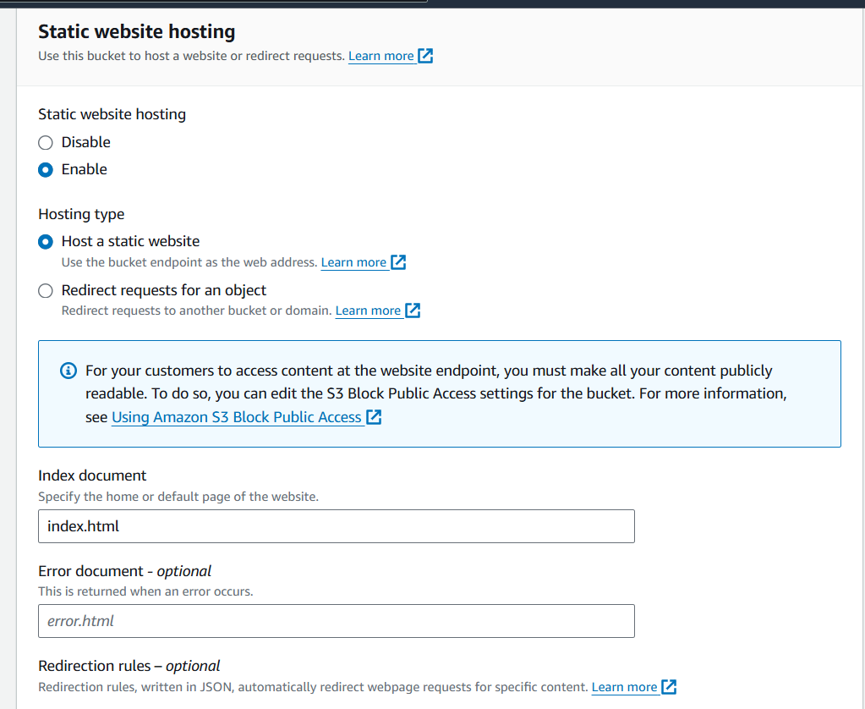

* Go to permission and edit bucket policy.
* Select bucket policy type -S3 bucket policy.
* Principle-\*
* Actions-Get object
* Paste your ARN in arn section.
* Generate policy and paste this policy in bucket policy. Add /\* in the end of your arn in policy.

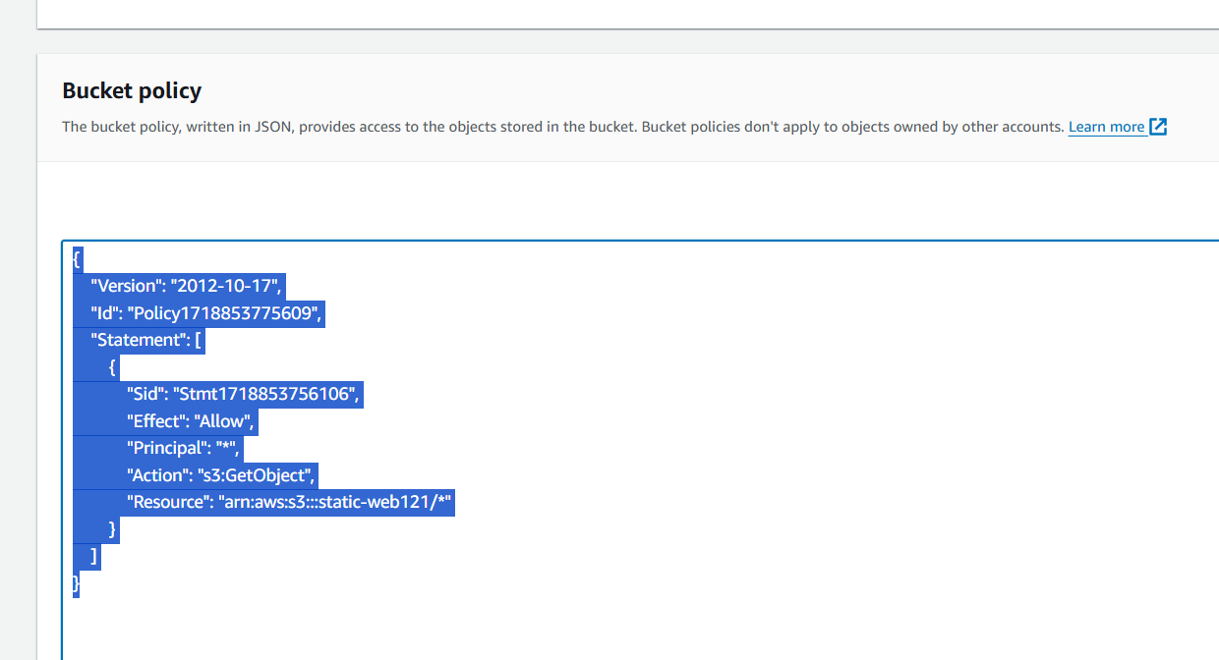

Creating html document

* Create a html, CSS and Java script code in Notepad.
* Save the file as Index.html

Uploading html file

* Go S3 bucket
* Click on Upload and Upload you html file.
* Link-

file:///E:/Clude%20computing/index.html

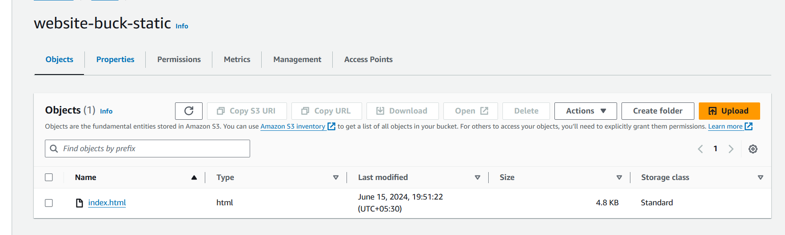

* Go to properties and copy static website link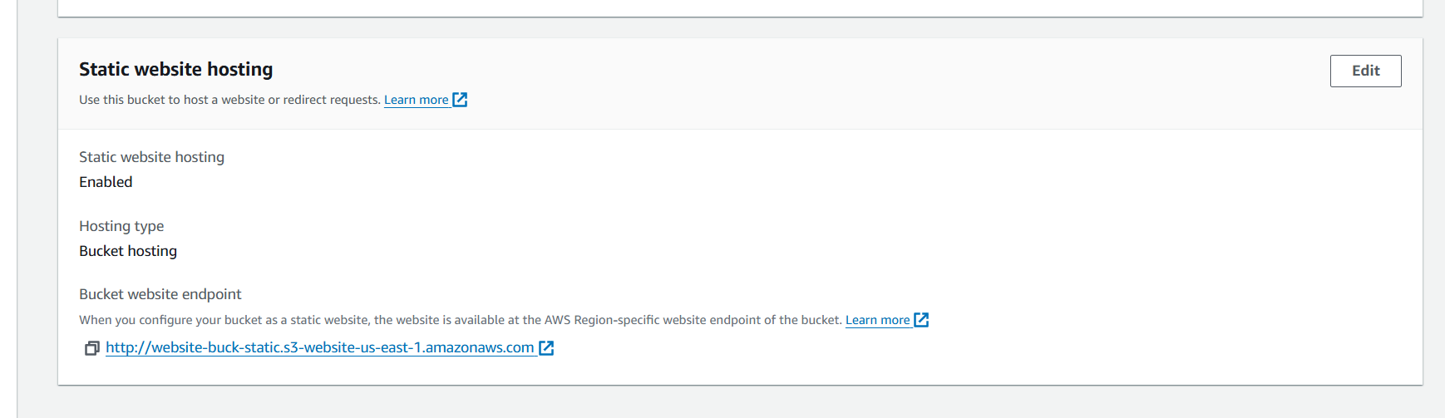
* Copy the URL in Brower.
* You will see a website open in your tab.

Result

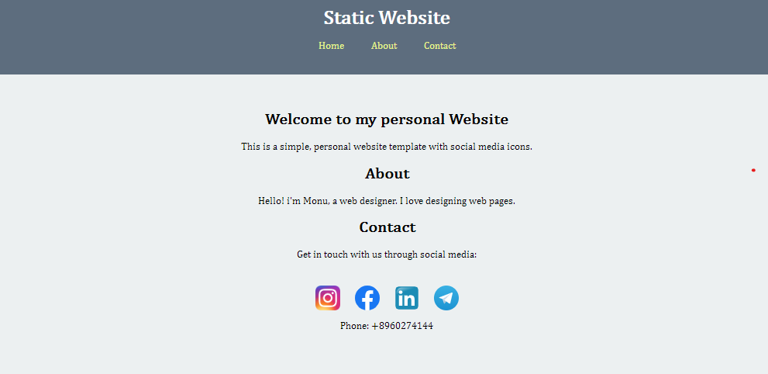

* If you enter wrong website link then this page will appear

